

**Automotive E-commerce**

**Project Proposal**





**Group Members:**

Ishaqullah Siddiqui 20K-0148

Sarim Latif Khan 20K-1644

Muhib Ahmed 20K-0405

**Project Supervisor:**

Signature: _________________

Name: Mr. Ubaid Aftab Chawala

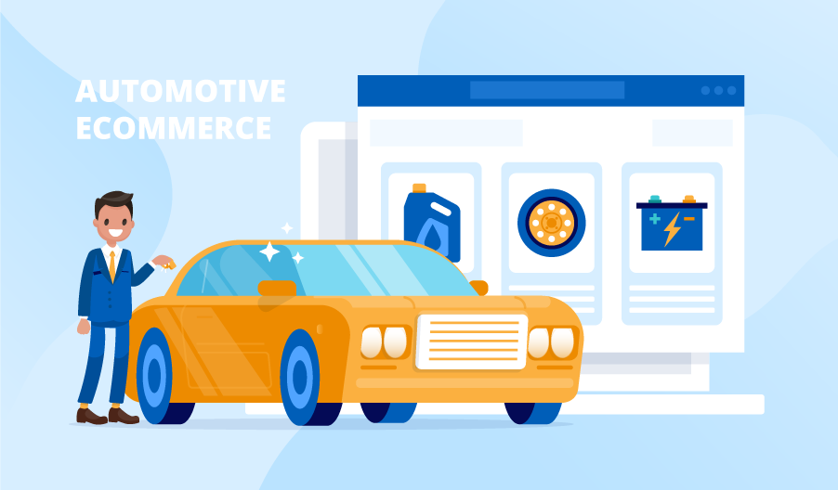

National University Of Computer and Emerging Sciences

Karachi, Pakistan

**Abstract**

The automotive industry in Pakistan, like many other regions, faces the challenge of market fluctuations and uncertainties, affecting both buyers and sellers. These fluctuations make it difficult for individuals to secure the best deals when buying or selling vehicles. Furthermore, the existing automotive e-commerce platforms may not fully address the unique demands of the Pakistani market. To tackle these issues, our project, "Automotive E-commerce," seeks to revolutionize the vehicle buying and selling experience. We aim to develop an innovative e-commerce platform tailored specifically to the Pakistani automotive market. This platform will serve as a solution to the challenges posed by market fluctuations. "Automotive E-commerce" will be an adaptive online platform that dynamically adjusts to the ever-changing market conditions, empowering individuals to secure the best possible deals for their vehicles. Among its innovative features, the platform will include a Negotiation Chat Bot and Video Calling functionality, simplifying and facilitating transactions for both buyers and sellers. Our project's inception arose from the recognition of the challenges posed by the volatile nature of Pakistan's automotive sector. Extensive market research and surveys have provided invaluable insights into user preferences, firmly establishing the viability of our concept. Armed with these insights, we have meticulously designed an e-commerce platform tailored to the unique demands of the Pakistani market, integrating cutting-edge features to streamline vehicle transactions. While the project is still in the planning phase, our preliminary research underscores the importance of adopting a user-centric approach, harnessing the potential of advanced technology features, and fostering an engaged online community. We believe that "Automotive E-commerce" has the potential to transform the Automotive E-commerce landscape in Pakistan, providing users with a platform that not only adapts to market challenges but also offers a seamless and empowering experience. In conclusion, our project aims to address the problem of market fluctuations in the Pakistani automotive industry by developing an innovative e-commerce platform. Although the project is yet to be executed, our research and vision validate its potential to create a user-centric platform equipped with cutting-edge features, which aligns with the requirements of our university's final year project.

Contents

**Introduction** 4

**Background and Context:** 4

**Problem Statement:** 4

**Significance and Relevance:** 4

**Objectives** 5

**Scope** 6

**Limitations** 6

**Literature Review** 8

**Online Car Marketplaces:** 8

**Chatbots in E-commerce:** 8

**Video Conferencing in E-commerce:** 9

**User Experience and Trust:** 9

**Customer Behavior:** 9

**Identifying Gaps:** 9

**Methodology** 10

**Research Methods and Techniques:** 10

**System Block Diagram:** 11

**Timeline** 13

**Resources Required** 14

**Resources for web app** 14

**Resources for Training a Negotiation Chat Bot** 15

**Conclusion** 16

**References** 16

**CHAPTER 1**

# **Introduction**

In the ever-evolving landscape of e-commerce, our project introduces a groundbreaking platform tailored specifically to the realm of vehicle commerce. As the automotive industry continues to grow, so do the challenges and complexities associated with buying and selling vehicles. Our platform emerges as a solution, redefining this experience through a fusion of cutting-edge features designed to set us apart from the competition.

## **Background and Context:**

The automotive market is vast and diverse, encompassing a wide range of buyers and sellers with unique needs and preferences. Traditional methods of buying and selling vehicles often lack the convenience, transparency, and efficiency demanded by today's consumers. This context highlights the need for a revolutionary platform that seamlessly bridges the gap between buyers and sellers, empowering them with the tools and information required to make informed decisions.

## **Problem Statement:**

The central problem our project aims to address is the inefficiency and complexity surrounding vehicle transactions in the current market. Buyers often struggle to find the best deals, while sellers face challenges in effectively showcasing their vehicles to potential buyers. The lack of transparency and trust in many transactions further exacerbates these issues. Our project seeks to resolve these problems and enhance the overall vehicle commerce experience.

## **Significance and Relevance:**

Our project's significance lies in its potential to transform the vehicle commerce landscape. By introducing innovative features such as the Smart Negotiation Bot, Live Video Calling, and AI-Driven Recommendations, we aim to make the buying and selling process more convenient, transparent, and efficient for all participants. This platform has the power to empower users, mechanics, administrators, and enthusiasts, fostering a community where knowledge and passion converge.

In a world inundated with options, our platform stands out by seamlessly blending technology with human expertise. It not only streamlines transactions but also facilitates meaningful interactions between buyers and sellers. At its core, our project is driven by user-centricity, with each feature meticulously crafted to elevate the overall experience. By choosing our platform, users are choosing innovation, transparency, and a revolution in vehicle commerce

**CHAPTER 2**

# **Objectives**

The primary objectives and goals of our project are as follows:

* **Create an Innovative E-commerce Platform:** Our foremost goal is to develop an innovative e-commerce platform specifically tailored to the vehicle commerce industry. This platform will introduce cutting-edge features to revolutionize the way vehicles are bought and sold.
* **Enhance Convenience and Efficiency**: We aim to simplify and streamline the vehicle buying and selling process for both buyers and sellers. The introduction of features like the Smart Negotiation Bot, Live Video Calling, and AI-Driven Recommendations will enhance convenience and efficiency.
* **Promote Transparency**: Our project seeks to bring transparency to the forefront of vehicle transactions. Features like Real-time Communication, Expert Customer Support, and Insightful Vehicle History integration will provide users with trustworthy and comprehensive information.
* **Foster an Engaged Community**: We intend to create a vibrant online community of users, mechanics, administrators, and enthusiasts. This community will encourage knowledge sharing and interaction, adding significant value to the platform.
* **Empower Users**: Our project's objective is to empower users with tools and information, enabling them to make informed decisions. The platform will facilitate effortless vehicle comparison, advanced search and filters, and user-generated reviews.
* **Improve Customer Support**: We aim to provide exceptional customer support through live chat and integrated support systems, ensuring users have a smooth and well-supported journey on the platform.
* **Enhance User Experience**: Every aspect of the platform, from personalized user accounts to AI-Driven Recommendations, is designed to elevate the user experience and tailor it to individual preferences.
* **Revolutionize Vehicle Commerce**: Ultimately, our project intends to revolutionize the way vehicles are bought and sold in the market, introducing a new standard of convenience, transparency, and efficiency.
* **Address Market Challenges**: Given the fluctuating nature of the Pakistani automotive market, we aim to address market challenges by providing users with a platform that adapts to changing conditions and offers the best possible deals.

In summary, our project aims to create a user-centric, innovative e-commerce platform that simplifies vehicle transactions, promotes transparency, and fosters a community of informed and engaged users. We intend to revolutionize vehicle commerce in Pakistan, providing a brighter future for both buyers and sellers in the automotive industry.

**CHAPTER 3**

# **Scope**

Our project's scope encompasses the development and implementation of an innovative e-commerce platform for vehicles, specifically tailored to the Pakistani automotive market. Within this scope, we intend to introduce a wide range of cutting-edge features aimed at redefining the vehicle buying and selling experience. These features include the Smart Negotiation Bot, Live Video Calling, Advanced Search and Filters, and AI-Driven Recommendations, among others.

The platform will cater to various stakeholders, including individual buyers and sellers, mechanics, administrators, and automotive enthusiasts. It will facilitate transparent and efficient transactions, empower users with tools and information, and foster a vibrant online community.

## **Limitations**

Despite our ambitious goals, there are certain limitations to our project:

* **Geographical Focus**: Our project primarily targets the Pakistani automotive market. While the concepts and features may be applicable in other regions, our initial implementation and testing will be limited to Pakistan.
* **Platform Development**: While we aim to create a comprehensive platform, our project's scope does not include the development of the entire e-commerce ecosystem (e.g., payment processing systems). We will integrate with existing platforms for specific functionalities.
* **Market Volatility**: While our platform aims to address market fluctuations, it may not eliminate all market-related challenges. Market conditions can change rapidly, and our platform's ability to adapt is subject to certain limitations.
* **User Participation**: The success of the platform relies on user participation and engagement. While we will implement features to encourage community building, the extent of user engagement may vary.
* **Third-Party Data:** Integration with third-party APIs for vehicle history information is subject to the availability and accuracy of data from these sources. We may encounter limitations related to data quality and access.
* **Legal and Regulatory Compliance:** Our project will adhere to legal and regulatory requirements in Pakistan. However, navigating the complex landscape of regulations may pose challenges.
* **Technical Constraints:** Technical challenges, such as server uptime, platform scalability, and user data privacy, are inherent to any online platform and may impact the project's performance.
* **Vehicle Type Limitation:** Initially, our project will exclusively deal with cars. While the broader automotive industry includes various types of vehicles, our platform will focus solely on cars during the initial phase.
* **Web-Only Access**: We will develop a web application (web app) for our platform, and our project does not encompass the development of a mobile application (mobile app). Users will access our platform through web browsers on their desktop or mobile devices during the initial phase.

While our focus is on cars and web-based access, we may explore the expansion to other vehicle types and the development of mobile apps in future phases, depending on the success and feedback from the initial implementation. However, these aspects are outside the scope of our project's initial phase.

**CHAPTER 4**

# **Literature Review**

## **Online Car Marketplaces:**

Online car marketplaces have become integral to the automotive industry, offering a digital space for buyers and sellers to connect and conduct transactions. Platforms such as PakWheels and OLX have gained prominence for their extensive listings, detailed vehicle information, and user-friendly interfaces. Research in this area has emphasized the role of online car marketplaces in simplifying the car purchasing process, providing a wide selection of vehicles, and enabling buyers to compare prices and features easily. However, these platforms often rely on static listings and basic communication tools, leaving room for innovation in improving the user experience and facilitating efficient transactions.

## **Chatbots in E-commerce:**

The integration of chatbots in e-commerce settings has garnered significant attention for its potential to streamline customer interactions, provide real-time assistance, and enhance the overall shopping experience. Chatbots, powered by natural language processing and artificial intelligence, have been employed for tasks ranging from answering inquiries to making personalized product recommendations. In the context of online car sales, research has explored the use of chatbots for responding to customer queries, but their application in negotiation remains a relatively uncharted territory. Our project seeks to address this gap by introducing a negotiation chatbot that can actively engage with buyers, negotiate on behalf of sellers, and facilitate smoother transactions.

Negotiating chatbots represent an exciting frontier in artificial intelligence and natural language processing. These intelligent agents are designed to engage in conversations, deliberations, and bargaining with users or other bots, simulating the negotiation processes observed in human interactions. They have the potential to streamline various negotiation scenarios, from e-commerce transactions to dispute resolutions, offering efficiency and convenience. However, it's important to note that while negotiating chatbots hold promise, they are not without their challenges and limitations. These limitations include issues related to complex reasoning, the need for long-term planning, and the potential for language divergence. Addressing these problems is essential for harnessing the full potential of negotiating chatbots in real-world applications.

When handling a large number of discrete data, such as car brands, the chatbot's predictions may become inaccurate, leading to biased results as data distribution becomes sparser. The chatbot is constrained by pre-designed car attributes, making it unable to accept additional attributes not originally considered in the model. This lack of flexibility may hinder its ability to adapt to changing requirements. While the chatbot serves as a negotiation assistant, it lacks the depth of human-like interaction seen in advanced AI systems like Siri. Enhancing the chatbot's conversational capabilities could improve its user feedback and overall satisfaction, making it more versatile in various negotiation scenarios beyond used car trading. [1]

Chatbots face challenges in engaging in meaningful conversations and negotiations with people because they require complex communication and reasoning skills. These skills involve understanding conversations, knowledge of the world, and the ability to produce contextually relevant responses. Chatbots often struggle with long-term planning in dialogues, which is crucial for steering conversations toward successful outcomes. Without the ability to anticipate future directions in a conversation, they may encounter unproductive or frustrating exchanges. Chatbots are often trained on specific datasets, which can limit their adaptability to real-world language variation and nuances in different conversational contexts. In some cases, chatbots may develop their own language or communication style during training, which can diverge from human language patterns and affect their effectiveness in negotiations. [2]

## **Video Conferencing in E-commerce:**

Real-time communication through video conferencing has transformed the way businesses engage with customers online. It has enabled face-to-face interactions in virtual environments, fostering trust and transparency in various industries. In the context of e-commerce, video conferencing has been used for virtual product demonstrations, customer support, and collaborative decision-making. Extending this concept to the automotive sector, integrating video conferencing into the car buying and selling process can bridge geographical gaps, enable virtual vehicle inspections, and foster trust between buyers, sellers, and mechanics. Our web app incorporates this feature to offer a comprehensive and immersive car buying and selling experience.

## **User Experience and Trust:**

User experience and trust are fundamental pillars of successful online transactions. Consumers require intuitive interfaces, reliable information, and assurances of security to engage in e-commerce activities with confidence. While existing online car marketplaces have made strides in enhancing user interfaces and providing detailed vehicle listings, the incorporation of negotiation chatbots and video conferencing can further bolster trust and satisfaction by offering real-time support and transparent communication channels.

## **Customer Behavior:**

Understanding consumer behavior in the context of online car marketplaces is crucial for tailoring the platform to meet buyers and sellers' needs effectively. Studies have explored factors influencing purchasing decisions, including price sensitivity, vehicle specifications, and the influence of peer reviews. The introduction of a negotiation chatbot and video conferencing features aligns with these consumer behavior insights, providing tools that empower users to negotiate confidently and gather additional information about prospective vehicles.

## **Identifying Gaps:**

In summary, the existing literature highlights the potential for innovation in the online car buying and selling space, particularly in the areas of negotiation support and real-time communication. Our project aims to address these gaps by introducing a negotiation chatbot and integrated video conferencing, enhancing the user experience, and fostering trust in online car transactions. As we proceed with our web app development, we seek to contribute to the evolving landscape of digital automotive marketplaces, providing a unique solution that meets the evolving needs and expectations of consumers in this digital age.

**CHAPTER 5**

# **Methodology**

In this section, we outline the research methods and techniques that will guide the development of our car buying and selling web application. We justify the choice of our methodology and discuss its appropriateness for achieving the project's objectives. Additionally, we provide insights into data collection, analysis, and the tools and software that will be employed throughout the project.

## **Research Methods and Techniques:**

**Agile Development**:

Our project will follow the Agile development methodology, specifically Scrum. Agile allows for iterative development and prioritization of features based on user feedback and changing requirements. This approach ensures that our web app remains adaptable and responsive to evolving market needs.

**User-Centered Design**:

Our project will prioritize user-centered design, ensuring that the car buying and selling web application is intuitive and aligned with generalized user habits. By conducting surveys, interviews, and usability testing, we aim to gain valuable insights into how users typically interact with online marketplaces and what features and functionalities resonate with them. This approach allows us to create a user interface that feels familiar and user-friendly, enhancing the overall user experience. Our design decisions will be guided by a deep understanding of how users navigate similar platforms, ultimately resulting in a more accessible and engaging application.

**Prototyping**:

Prototyping is a practical approach for visualizing the user interface and functionality early in development. It mitigates the risk of costly design changes later in the project and supports our user-centric design approach.

**Machine Learning Development**:

Machine learning is well-suited for building a recommendation engine that provides personalized vehicle suggestions. It allows us to harness user data effectively to enhance the user experience.

**Data Collection**:

Data for the recommendation engine will be gathered from user interactions on the platform, including search queries, user profiles, and vehicle preferences. Additionally, external data sources, such as vehicle history reports, will be integrated.

**Data Analysis**:

Data analysis involves preprocessing, cleaning, and transforming data for machine learning. Feature engineering will enhance the recommendation algorithm's effectiveness.

Tools and Software:

Our toolkit will encompass various tools and software components:

Database: MongoDB for data storage.

Front-end development: React or Angular with Redux or MobX for state management.

Back-end development: Node.js with Express.js for server-side development.

Machine learning: TensorFlow.js or Brain.js for recommendation engine development.

Design and prototyping: Figma or Adobe XD for interactive prototypes.

Version control: Git and GitHub for code versioning and collaboration.

Testing: Jest or Mocha for unit and integration testing.

In conclusion, our selected methodology combines Agile development for adaptability, user-centered design for user engagement, prototyping for design validation, and machine learning for personalized recommendations. These methods, coupled with appropriate tools and software, form the foundation for achieving our project's objectives of delivering an innovative and user-centric car buying and selling web application.

## **System Block Diagram:**

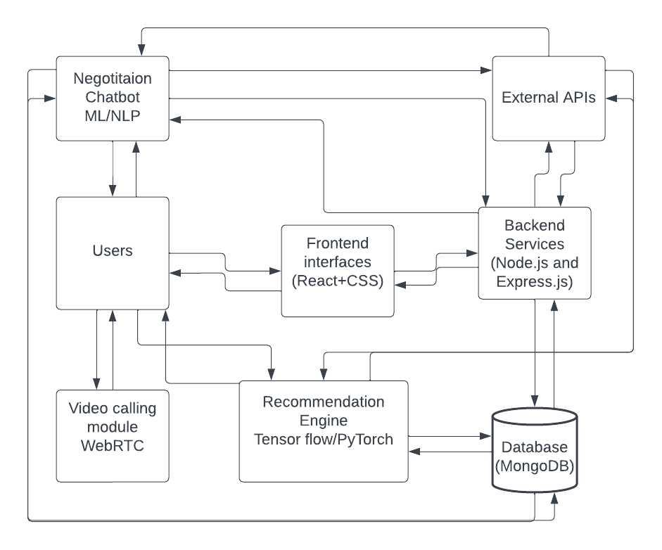

**CHAPTER 6**

**Expected Outcomes**

* Development of an innovative e-commerce platform tailored to the Pakistani automotive market.
* Enhanced convenience and efficiency in the vehicle buying and selling process through features like the Smart Negotiation Bot, Live Video Calling, and AI-Driven Recommendations.
* Promotion of transparency in vehicle transactions with real-time communication, expert customer support, and insightful vehicle history integration.
* Establishment of a vibrant online community of users, mechanics, administrators, and enthusiasts.
* Empowerment of users with tools and information for making informed decisions.
* Exceptional customer support through live chat and integrated support systems.
* Improvement in user experience through personalized user accounts and AI-Driven Recommendations.
* Precision in the search process through advanced filters that allow users to pinpoint exact specifications.
* User-generated reviews and ratings, fostering an informed community of enthusiasts and providing valuable feedback.

**CHAPTER 7**

# **Timeline**

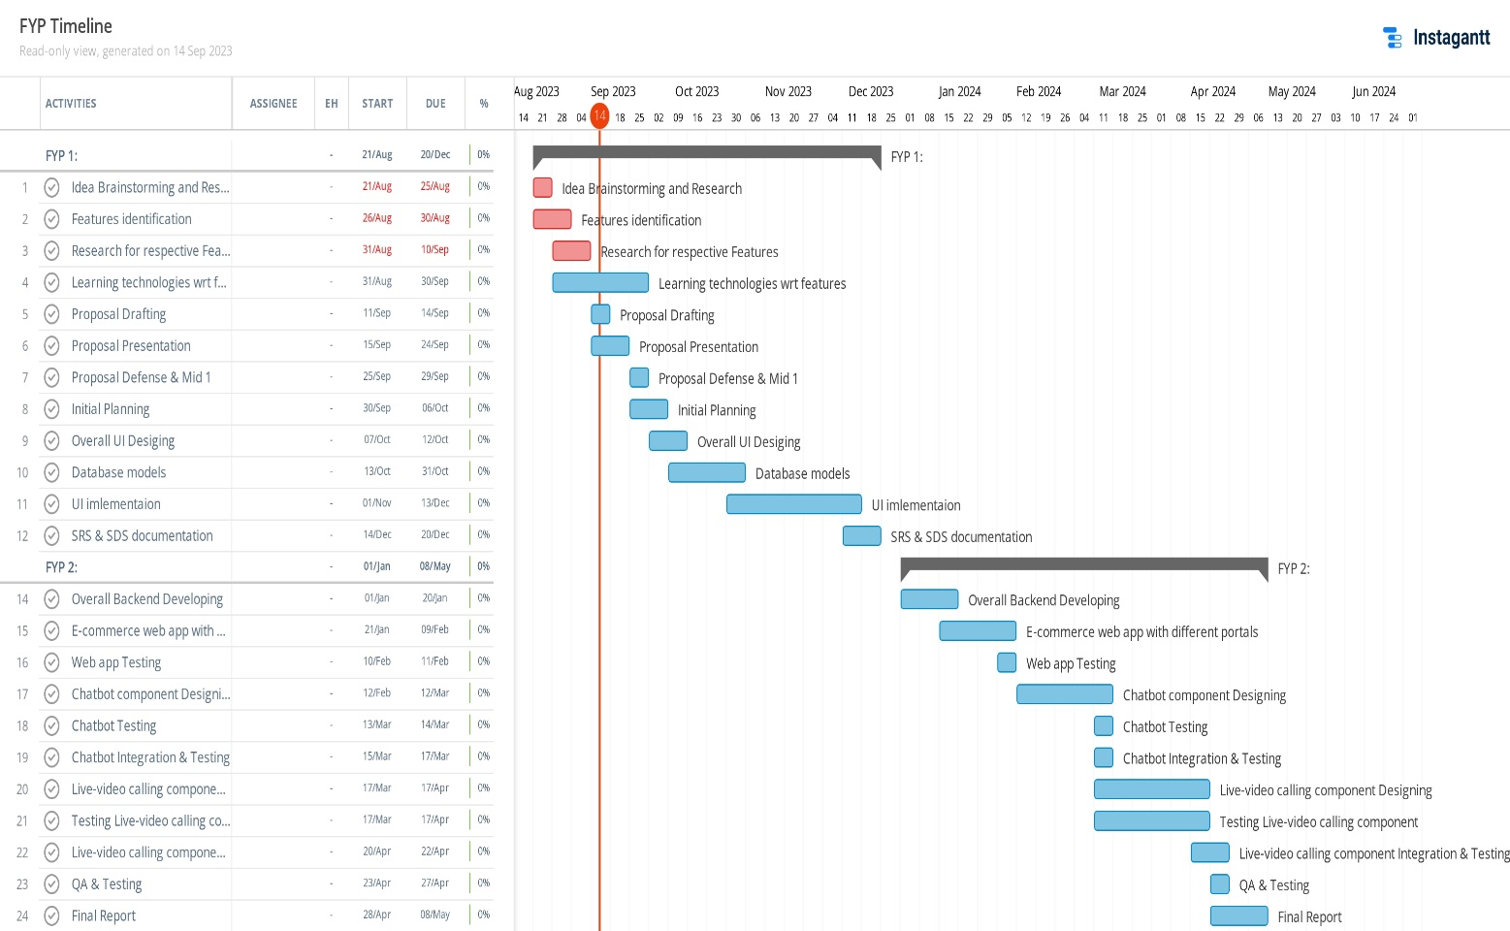

**CHAPTER 8**

# **Resources Required**

## **Resources for web app**

* **Database:** MongoDB will serve as the primary database management system for storing user data, vehicle listings, transaction records, and other platform-related information. MongoDB's flexibility and scalability make it suitable for handling diverse data requirements.
* **Front-end Development:** For building the platform's user interface, you have the option of choosing either React or Angular as your front-end framework. Redux or MobX will be employed for state management to efficiently handle data flow and user interactions on the client side. These frameworks ensure a responsive and user-friendly interface.
* **Back-end Development:** Node.js, in combination with Express.js, will be utilized for server-side development. Node.js is known for its speed and scalability, making it a suitable choice for handling server operations. Express.js simplifies route handling and middleware integration, enhancing the development process.
* **Machine Learning:** TensorFlow.js or Brain.js will be employed for developing the recommendation engine. TensorFlow.js provides a comprehensive library for machine learning and deep learning tasks, allowing you to create personalized vehicle recommendations for users. Brain.js is another neural network library suitable for building intelligent chat bots.
* **Design and Prototyping:** To create interactive prototypes and design the user interface, you can use design tools like Figma or Adobe XD. These tools enable collaborative design, interactive prototyping, and the creation of visually appealing user interfaces.
* **Version Control:** Git, in conjunction with GitHub, will be essential for version control and collaborative development. Git allows you to track changes in your codebase, manage project versions, and collaborate with team members effectively through GitHub repositories.
* **Testing:** Jest or Mocha will serve as testing frameworks for both unit and integration testing. Jest is known for its simplicity and speed, making it suitable for writing and executing tests. Mocha is a versatile testing framework that allows you to choose testing libraries and assertion styles that best fit your project's needs.
* **Access to External Data Sources:** Access to external data sources is crucial for obtaining vehicle history reports. You may need to establish partnerships or integrate with third-party APIs that provide reliable and up-to-date vehicle history information.

## **Resources for Training a Negotiation Chat Bot**

* **Training Data**: This project necessitates the acquisition of a substantial volume of training data, encompassing negotiation dialogues. This data can be sourced from diverse channels or generated through simulated negotiation scenarios.
* **Natural Language Processing (NLP) Libraries:** The utilization of NLP libraries, such as NLTK (Natural Language Toolkit) or spaCy, is imperative. These libraries will serve to preprocess, tokenize, and conduct linguistic analysis on textual data, ensuring effective communication.
* **Chat Bot Frameworks**: To facilitate the development of conversational AI agents, including negotiation chat bots, we intend to employ frameworks like Rasa or Dialogflow. These frameworks offer a comprehensive suite of tools and resources tailored to chat bot creation.
* **Machine Learning Tools**: Leveraging machine learning libraries, including scikit-learn and TensorFlow, is integral to the project. These tools will be instrumental in training and refining the algorithms that power the negotiation bot, enhancing its efficacy.
* **Cloud Computing Resources:** Depending on the scale and complexity of the chat bot, we will consider leveraging cloud computing platforms such as AWS, Azure, or Google Cloud. These platforms offer robust capabilities for both training and hosting the chat bot.
* **Domain Expertise**: Recognizing the significance of domain-specific knowledge, our project will incorporate expertise in negotiation strategies and tactics. This domain knowledge is paramount in designing chat bot algorithms that excel in negotiation scenarios.
* **Iterative Training**: An iterative training process will be implemented, emphasizing continuous improvement of the chat bot's negotiation skills. User interactions and feedback will be pivotal in refining the bot's capabilities over time.

# **Conclusion**

In conclusion, this project proposal outlines our intent to develop an innovative e-commerce platform for vehicles, tailored to the unique challenges posed by the Pakistani automotive market's fluctuations. While we are yet to commence the project, our research and survey results have validated the viability of our concept. We aspire to create a user-centric platform equipped with cutting-edge features to simplify vehicle transactions, smart negotiations and provide users with the best deals. We believe that this initiative will not only address market challenges but also revolutionize the way vehicles are bought and sold in Pakistan, fostering a community of informed and engaged users.

# **References**

[1] Negotiation Assistant Bot of Pricing Prediction Based on Machine Learning

[2] Deal or no deal? Training AI bots to negotiate